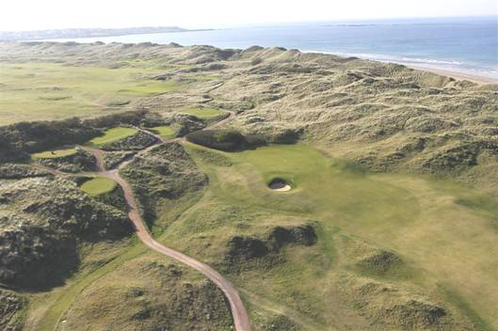

**The 148th Open will be played at Royal Portrush from 14-21 July 2019,** marking a historic return to Northern Ireland for golf’s oldest and most international Championship after nearly 70 years.  
The Open was last staged at Royal Portrush in 1951, when Max Faulkner became Champion Golfer of the Year.

Northern Ireland will be at the centre of the global sporting spotlight when

The Open is staged outside of Scotland and England for only the second time in the Championship’s more than 150-year history.  
Sports fans from throughout Ireland and around the world are expected to descend upon the town of Portrush to watch the world’s greatest golfers compete for the iconic Claret Jug.*Royal Portrush*